Guest Booking Form 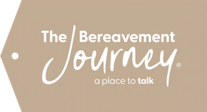
The Bereavement Journey® is a 7-session programme which assists bereaved people to process their loss. Guests do their own grief work. Each session comprises two films followed by discussion in a small group, facilitated by volunteers, and with a light refreshment to begin the evening.

Organisers: Minchinhampton Holy Trinity and Baptist Churches: Tel: Sue 01453 873136
Course Dates: Thursdays June 4th 11th 18th 25th July 2nd 9th 16th 2026
Times: From 7.00 p.m. to 9.00 p.m. in the Minchinhampton Parish Church - Porch Room
Cost: £25 contribution for course manual and refreshments. Payment at first session by cash/card please.
Please email this form to suefairley1@outlook.com or courses@minchbc.org.uk
Or post to Minchinhampton Baptist Church, Tetbury Street, Minchinhampton, GL6 9JH

First Name: Last Name:

Email address: Phone number:

Postal address:

Please tick Age: 18-30 31-40 41-50 51-60 61-70 71+ Prefer not to say
If you are registering for the course for a reason other than that you have been bereaved recently or in the past, please contact the event organisers.
Please tell us if you have any dietary issues: Vegetarian Vegan

or other specific needs please indicated below:

